Document No.:
Receiving Date:
(For APFNet Secretariat)

Asia-Pacific Network for Sustainable Forest Management and Rehabilitation

Project Completion Report

【Supporting to Develop New Forest Sector Policy and Strategy through Consultation with Civil Society Organizations and Local Communities in Nepal (NEP/2013/PD)】

May, 2013 – April, 2014

Supervisory Agency
Ministry of Forests and Soil Conservation, Government of Nepal
Executing Agency
Federation of Community Forestry Users’ Nepal (FECOFUN)

July, 2014

Basic Information
Project Title(ID) | NEP/2013/PD
Supervisory Agency | Ministry of Forests and Soil Conservation, Government of Nepal
Executing Agency | Federation of Community Forestry Users, Nepal (FECOFUN)
Implementing Agency
Date of Project Agreement: [26/January/2013]
Duration of implementation: [May/2013-April/2014]
Total project budget(in USD) |  | 109000 |  | APFNet assured Grant (in USD) |  | 100000
Actual project cost(in USD) |  |  |  | APFNet disbursed Grant(in USD) |  | 90000
Disbursement Status |  |  | Date of disbursement |  | Amount
Initial disbursement |  |  | 18, June, 2013 |  | 50000 USD
Second disbursement |  |  | 26, December, 2013 |  | 40000 USD
Last disbursement(balance to be disbursed) |  |  | To be disbursed |  | 10000 USD
Reporting Status |  |  | schedule implementation |  | Project progress status
First reporting (1,June, 2013 to August, 31, 2013) |  |  | On track |  | Satisfactory
Second reporting ( September, 2013 to February, 2014)  2-1 |  |  | On track |  | Satisfactory

Project Steering Committee Members

1. Apsara Chapagain,
Chairperson, FECOFUN
chapagainap@yahoo.com

2. Ganesh Bahadur Karki,
General Secretary, FECOFUN
karkign@gmail.com

3. Ram Parsad Lamsal
Joint Secreatary, MoFSC/GoN
APFNet Focal Point in Nepal
rplamsal1@yahoo.com

4. Naya Sharma Poudel,
Forestry and Civil society Expert, Forest Action Nepal
naya@forestaction.org

5. Suvas Chandra Devkota,
Project Director, FECOFUN
suvas.devkota@gmail.com

ABBREVIATION

APFNet Asia Pacific Network for Sustainable Forest Management and Rehabilitation
CF Community Forestry
CFUGs Community forestry Users Groups
CDO Community Development Organization
COFSUN Community Forestry Supporters Organization, Nepal
CSO Civil Society Organizations
DFO District Forest Office
DoF Department of Forest
FECOFUN Federation of Community Forestry Users, Nepal
FOP Forest Operational Plan
FSS Forestry Sector Strategy
GG Good Governance
GoN Government of Nepal
HIMAWANTI Himalayan Grassroots Women's Natural Resource Management Association
MoFSC Ministry of Forests and Soil Conservation
MPFS Master Plan for Forestry Sector
I/NGO International /Non-Government Organizations
NPC National Planning Commission
NTFPs Non-Timber Forest Products
REDD Reducing Emission from Deforestation and Forest Degradation
SFM Sustainable Forest Management

Executive Summary
The project “Supporting to Develop New Forest Sector Policy and Strategy through Consultation with Civil Society Organizations and Local Communities in Nepal” has been implemented since May 2013. The overall goal of the one year project supported by APFNet was to provide policy suggestion and feedback to MoFSC and National Planning Commission through wider mobilization and consultations among policy makers’ social and technical experts, local communities and civil society organizations. Community, district, regional and national level consultations workshops, multi stakeholder discussion, preparation of policy review document, preparation and official submission of policy suggestion report to Ministry of Forests and Soil Conservation (MoFSC) and media mobilization are the major activities implemented by the project.
MPFS, international agreements, conventions, forestry policies and regulations and NPC plan on forest and soil conservation were reviewed which helped to provide policy feedback to MFSC and NPC whereas the interaction with multi-stakeholders helped to facilitate to Government and other stakeholders to make common understanding on forestry sector issues. The policy analysis document comprehends the situation and helped to give policy recommendations to MoFSC.
Multi-Stakeholder consultation at various level such as community level, district level , regional level were conducted with active participation of community forestry user groups, diverse groups of forest-dependent peoples, local government officials, representatives from community groups, government stakeholders and civil society organizations.

Consultation workshops conducted at various levels were very much fruitful in grasping the local level issues related to community forest management, benefit sharing, addressing the issue of distant users, promotion of forest based enterprises and transformation of forestry sector in the context of state restructuring, as a policy feedback for the new forestry sector strategy. Forest users, government officials, local level stakeholders actively raised their voice in support of community based forest management ensuring the right of local users in forest management and benefit sharing. These workshops recommended that the new forestry sector strategy must prioritize community based forest management as the forest management strategy for the future based on its achievement. National consultation cum sharing workshop was organized in Kathmandu to share the findings of various consultations and to develop common understanding among national level stakeholders in forestry sector issues. The major participants of consultation were high government forestry officials form MoFSC, Constitutional Assembly members, I/NGO representative, FECOFUN executive and central committee members, Forestry experts, Policy researchers, policy makers and Media persons.
Multi-stakeholders (both Government and civil society organization of forestry sectors, community organizations, CFUGs and others) consultations helped to facilitate the Government and other stakeholders to make common understanding on forestry sector issues.
Preparation of policy review document and submission of policy recommendations to MoFSC is the major outputs of this project. The policy suggestion report has been prepared based on the consultation done at various level and the gaps identified in the policy review document. The policy suggestion report has been officially submitted to MoFSC. The major points highlighted in the policy suggestion repots are prioritization of community forestry program as primary program, restructuring of forestry organization, formulation of conducive policies and initiation of sustainable forest management and enterprises. Media mobilization was done to disseminate the project outputs as well as policy recommendations among wider stakeholder. Interaction and consultation was also done with media personnel’s to collect their views in current issues.
The project progress towards the achievement of the project specific objectives and expected outcomes is satisfactory as the planned activities have been completed. This project intervened on the policy making process, engaged the local communities and other stakeholders in series of consultation to grasp the grass rot voices. It has also developed the common understanding among the various stakeholders as a result of which a single policy recommendations document has been submitted to MoFSC by FECOFUN representing civil society organizations of Nepal.

TABLE OF CONTENTS
1. BACKGROUND AND INTRODUCTION 1
1.1. Project Context 1
1.2. Project Goal and objectives 2
1.3. Project expected outputs and outcomes 3
2. PROJECT IMPLEMENTATION 3
2.1. Project schedule and implementation arrangements 3
2.2. Project Resources and costs 4
2.3. Procurement and consultant recruitment 5
2.4. Monitoring, Evaluation and Reporting 5
2.5. Dissemination and Knowledge sharing 6
3. PROJECT PARTNERS’ PERFORMANCE 6
3.1. Performance of the Supervisory Agency 6
3.2. Performance of the Executing Agency 6
3.3. Performance of APFNet 7
4. PROJECT PERFORMANCE 7
4.1. Achievements 8
4.2. Impacts 13
4.3. Sustainability 13
5. CONCLUSION, LESSON LEARNED AND RECOMENDATIONS 14
5.1. Conclusion 14
5.2. Lessons learned 14

BACKGROUND AND INTRODUCTION

Project Context
Nepal’s historic 22-year Master Plan for the Forestry Sector (MPFS) ended in 2011 leading to inclusion of proposal in the Three Years Interim Plan and Approach paper for development of new forest sector policy and strategy in line with the changing socio-economic and political context. Realizing the need for developing new forest sector strategy in order to guide governance, conservation and management and economic development through forestry sector, Ministry of Forest and Soil Conservation (MoFSC) has been working on development of new forest sector strategy by this year.
In order to gain acceptance and common ownership of people along with wide stakeholders involved in forestry sector, consultation with local communities directly involved in conserving and managing forests as well as those involved in development of forestry sector would be highly necessary. The need for such strategy is especially critical as forest rights and institutions are being negotiated at constitutional levels, and also because donors and forestry related agencies are planning to move through new cycles of funding and programming in the forestry sector. FECOFUN being the representative of community forestry user groups can provide the critical analysis and ground suggestion with CSOs and local community to the MoFSC so that government agencies can come together for planning and developing new forest sector policies and strategies that can be implemented without hurdles. It created an opportunity for FECOFUN and MoFSC to develop forest sector strategy that informs, and is sensitive to the transitional political system of the country, while aiming to institutionalize the recent political achievements to transform forestry sector of Nepal. Unlike earlier forest sector plans, the proposed Forest sector strategy will go beyond the confinements of traditional forestry domain, and will address several crosscutting issues such as climate change, biodiversity conservation, poverty reduction, active and sustainable forest management, economic development and local livelihoods, social inclusion, democratic governance, tenure and rights over the resources issues.

Nepal’s forestry sector has been facing unprecedented transitions in various respects. The political-economic and global context of forest governance has changed dramatically since the inception of the MPFS. More specifically, the country has been rapidly moving through political transition in which issues of rights, inclusion, governance, economic development and equity have surfaced more strongly than ever before. The entire structure of the state has been challenged, while visions for democratic and inclusive governance are being articulated at different spheres of polity, through various forms of resistance politics and policy negotiations. Over the past 40 years, forest dependent communities have emerged as the key players in the forest governance, mostly as a result of the visionary guidance of the MPFS and periodic plans created by Ministry of Forests and Soil Conservation (MoFSC) and the National Planning Commission (NPC).

The emergence of local communities and civil society organizations (CSOs) as the key players of forest governance has posed significant challenge to established institutions and knowledge about forest and forestry, opening up possibilities for people-centered and equitable management of forest resources. Yet, as the process of drafting the new constitution of the country proceeds, albeit slowly, there is now an intensified debate on how rights over forest and related resources management should be defined and secured in the context of emerging federal structure of the state. Apart from these endogenous politics, the way forest is governed and managed is also significantly influenced by the emerging crisis of climate change, which is creating additional challenges to local communities, and to some extent opportunities through possible carbon financing and REDD mechanism.
In this context the project was designed to support forestry sector policy and strategy development process. It aimed to provide the policy recommendations to the government which will be critical for the formulation of new forestry sector strategy. There is difference in among various stakeholders in understanding various issues, so there needed to develop common understanding among these stakeholders and civil society organizations to have a real impact on policy formulation.

Project Goal and objectives
The overall Goal of the project was to provide policy recommendations to MoFSC and National Planning Commission with civil society perspective through the wider mobilization and consultations among policy makers, social and technical experts, civil society organizations, community organizations and federations.
The specific objectives of the project were:
- Review existing forest policies specifically Master Plan for Forestry Sector (MPFS), international agreements and forestry sub sector plans of National Planning Commission and other ministries.
- Develop common understanding among wider stakeholders and incorporate their views to support in developing participatory forestry sector strategy.
- Enhance understanding of contemporary forestry development for key representatives from CSOs, Ministry of Forest and Soil Conservation and local communities.
- Support in process of integrating suggestions and feedbacks in formation of forest sector policies and strategies.

Project expected outputs and outcomes
The project aims that the MPFS will be facilitated in the process of suggestions and feedbacks integration to the forest sector policies and strategies developed. It will help to support to develop long-term vision and strategic plan of forestry sector through capitalization of skills, knowledge and experiences of local communities in policy making process as well as making common understanding among different actors of forestry sectors on the issues and policy making process. The expected outputs were as follows

- Documented gaps in the existing forestry policies of Nepal focusing on international forestry development and sustainable forest management

- Prepared set of key thematic areas and points needed to be incorporated in the new forestry sector strategy

- Enhanced knowledge on sustainable forest management and international forestry development among CSOs representatives, FECOFUN, local community and representatives of Ministry of Forest and Soil Conservation.

- Feedbacks and suggestions of wider stakeholder regarding new forestry sector strategy reached to respective stakeholders for action

PROJECT IMPLEMENTATION

Project schedule and implementation arrangements
The project has been implemented officially since May 2013. The duration of project was of 1 year till the April 2013. The project work plan was formulated for the project period to implement the different activities in consultation with different stakeholders. The glimpse of overall work plan is shown in (Annex-1).
The project was implemented in joint coordination and collaboration between other Civil Society Organizations (CSOs) but FECOFUN led and implemented the project as the executing agency. A high-level five member Project Steering Committee (PSC) with members from FECOFUN, MoFSC and other forestry and social experts was formed for the overall guidance of the project. The PSC meeting selected the project director (PD) for executing overall management responsibility of the project. The PD was also the secretary of the PSC. The Project Director was responsible for overall management of project activities as a leader on behalf FECOFUN under the supervision of MoFSC.
The PSC supervised project implementation and management make vital decisions and guide the project in providing strategic and policy support. The project director coordinated the PSC meetings, documented the major decisions of the meetings and implemented it during execution of the project activities.
The community, district, regional and national level consultation workshops were implemented with collaboration with FECOFUN district chapters other CSOs and government line agencies. Preparation of policy analysis document was done by the consultants in coordination with project team. All the issues, feedbacks, comments raised during the meetings, workshops and dialogues were duly documented and shared with in the PSC and executing agency. The international policy observation tour in china was managed by APFNet.
The overall project management structure is shown below.
FECOFUN/ Project Management Unit

Center level activities
Supervisory Agency
- Project Director
- Consultants and experts, Accountant
- Local resources persons

Regional level activities
District level activities
Community level activities
Project Steering Committee
Fig: Project management structure

Project Resources and costs
There were two types of funding sources for implementation of this project. One is APFNet grant and another is counterpart fund. The counterpart fund was in in kind which was contributed by FECOFUN. The total cost of the project was US$109,900. Out of which grant from APFNet was US$ 100,000 and reaming as counterpart fund from FECOFUN in the form contribution in kind. The most of the funding was used according to the project budget in the consultation process. The expenditure was in line with the budget. The financial detail is presented in separate financial report and project completion audit report.

Procurement and consultant recruitment
The procurement of necessary goods and equipment for the office were procured as per the Public Procurement Act 2007 and Financial Regulations of FECOFUN. All of the fixed assets were used from the earlier APFNet funded project so no major assets were procured during this project period. The fixed assets list is provided in previous project completion report sent to APFNet.
As per need of the project, a number of short-term consultants were hired during the implementation of the project. Some key consultants that were used during the implementation of various activities are:
- Carry out the assessment of the achievements, challenges and lesson learned of the implementation of the Master Plan for the Forestry Sector.
- Review of international agreements and forestry sector sub plan of national planning commission
- Consultation meetings, feedback collection and draft of policy analysis review report preparation
- Finalizing policy analysis document and dissemination
Consultants input
Name | Expertise | Time Period | Contribution
Mr. Netra Timsina | Civil Society Development and Policy Expert | June 2013 to December 2013 | Review of forestry strategy and Policy
Mr. Ghan Shyam Pandey | GACF Coordinator (Social Expert) | June 2013 to December 2013 | facilitation at various level of consultation workshops
Mr. Bhola Khatiwada | Facilitation Expert | June 2013 to November 2013 | Facilitation at various level of workshop
Mr. Shomat Ghimire | Social Expert | June 2013 to November 2013 | Facilitation at different level of consultation workshop
Mr. Lok Raj Nepal | Forestry Expert | June 2013 to December 2013 | Review of MPFS and forestry Policy

All of the consultants used in the process were local consultants. The overall performance of the consultant was satisfactory as all of them coordinated well with FECOFUN and finished their task in given time period.

Monitoring, Evaluation and Reporting
Monitoring and Evaluation
There has been timely monitoring of the project activities through various means. At central level, the project progress was discussed in a meeting with steering committee members and project staffs periodically. The project progress was monitored by national executive committee members every quarterly, Monitoring and Evaluation Committee of FECOFUN and also by Project Steering Committee members on an as needed basis. An internal monitoring report is annexed to this report, as shown in (Annex-2).
Reporting
The project submitted two Quarterly Performance Reports to APFNet each of which covered the progress of activities of four months period. This is the final project completion report which encompasses progress of all of the activities of the project of one year.

Dissemination and Knowledge sharing
Series of multi stakeholder dialogues were organized to share the various issues and feedbacks raised during the local level consultations. Forest Action Nepal, COFSUN, CDO, HIMAWANTI and Green Foundation Nepal, were the major CSOs that were coordinated and consultated in various multi stakeholder dialogues. It helped to create the framework for the further consultations. Various Media personnel’s and media houses were mobilized during the project period. Media mobilization helped to disseminate the findings and recommendations of the consultation. This also helped to create the common understanding among the various national and local stakeholders.

ROJECT PARTNERS’ PERFORMANCE

Performance of the Supervisory Agency
Ministry of forests and soil conservation, government of Nepal was the supervisory agency for this project, played a supportive role to implement various activities in national as well as local level. Forestry officials from local as well as national level actively participated in various consultation workshops. There was close coordination and collaboration between the executive agency and the supervisory agency. Meetings, discussions and progress sharing events were organized regularly, which helped to create cohesiveness and enabling environment for activity implementation and policy lobby.

Performance of the Executing Agency
The program team comprised of Federation of Community Forestry Users, Nepal (FECOFUN) as the Executing Agency and served as the executor of the project. The executive agency had overall programmatic, administrative and management responsibility for the project. FECOFUN played the satisfactory role in implementing the project. Project activities were completed in the scheduled time period, financial expenditure was in line with the project budget and the targeted project outputs were duly achieved. Based on this the performance rating of the executive agency is presented below.

Table 1: performance rating sheet of executing agency

Performance Indicators | Score
Time Control | 4.5
Cost Control | 4.5
Adherence to Contractual Conditions | 4
Adequacy of Supervision and Reports | 4
Operational Performance | 4.5
Total (Average) | 4.25 ( satisfactory )

Performance of APFNet
APFNet being the financial supporter for this project, showed the higher degree of coordination and collaboration during the project implementation period. The fund transfer was in time as schedule in the project document. Without its support and guidance project wouldn’t have achieved its goal and objectives. The performance of APFNet can be viewed as follows
- Good coordination and collaboration with executing agency during the project implementation.
- Support in technical and managerial skills to project team.
- Support to international policy observation tour.

PROJECT PERFORMANCE
The planned activities of the project were successfully completed in scheduled time. Consultation workshops conducted at various levels were very much fruitful in grasping the local level issues related to community forest management, benefit sharing, addressing the issue of distant users, forest based enterprises issues and transformation of forestry sector in the context of state restructuring as a policy feedback for the new forestry sector strategy. Forest users, government officials, local level stakeholders actively raised their voice in support of community based forest management ensuring the right of local users. These workshops recommended that the new forestry sector strategy must prioritize community based sustainable forest management as the forest management approach for the future. Separate report of each community level, district, region and national level workshop is prepared. All the issues and ideas raised during these consultations are duly documented as a separate consultation workshop reports. Photos plates of the consultation workshop are also included in the report.
Preparation of policy review document and policy suggestion report is the major outputs of this project. The policy suggestion report has been prepared based on the consultation done at various level and the gaps identified in the policy review document. The policy suggestion report has been officially submitted to MoFSC. The major points highlighted in the policy suggestion repots are prioritization of community forestry program as primary program, restructuring of forestry organization, formulation of conducive policies and initiation of sustainable forest management and enterprises .
Media mobilization is an important part of this project. Information regarding the feedbacks and suggestion collected during various consultations were shared among different media personnel’s. A press conference was also organized to share on the policy suggestion report submitted to MoFSC. Project target versus achievement is in (Annex-9).

Achievements
4.1.1 Documented gaps in the existing forestry policies of Nepal focusing on international forestry development and sustainable forest management
Several levels of Expert consultation was carried out on reviewing different documents such as existing MPFS, International agreement and NPC forestry sub sector plan, which helped to develop the policy review document and to provide policy feedback to MoFSC, to develop a new national forest strategy jointly with government and civil society organizations. Some of the major findings and gaps based on review of MPFS and other forestry policies are discussed below.
In Nepal, 24 years has been past after the enactment of the Master Plan for the Forestry Sector (MPFS). In these 24 years, the forestry sector itself has faced several ups and down as there has been tremendous changes in the socio-economic context of the rural villages of Nepal. There have been changes in the relationship between villages and urban centres as high rate of migration from village to urban and abroad has been observed. As a result, villages face shortage of labour both for agriculture and forestry related works. There has not been any study conducted on the changing context and impact to forestry sector.
In the last 30 years, community forestry has been a successful approach of rural development in Nepal and also lessons were scaled up and out to the outside of Nepal. The community rights oriented policy had empower the forest user groups not only in the front of forest management, but also taking part in the decision making process of local affairs that directly affect them.
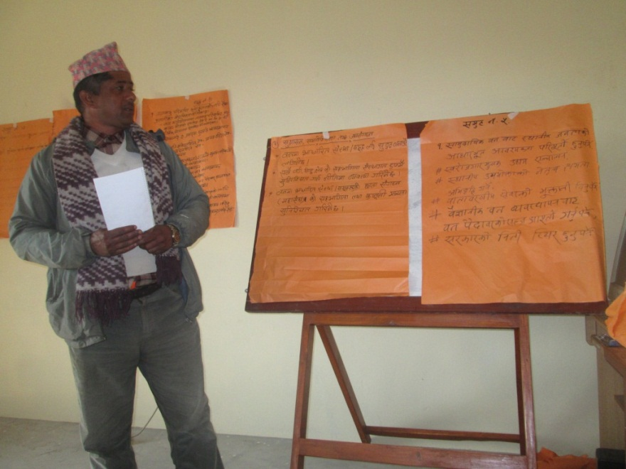
Ministry of Forest and Soil Conservation has attempted to amend the Forest Act particularly for curtailing the autonomy of CFUG. The first attempt was made in 1998 and other several subsequent attempts were made and the recent was in 2012. The trend is that the forest administration attempts to amend when the political fragility exists in the country. After the first attempt in 1998, the forest bureaucracy turned to be reluctant to facilitate community forestry in the same spirit they were facilitating before. All the attempts have been unsuccessful as there were vehement protests by FECOFUN against the Act amendment attempts. The seed of the conflict between the community and forest bureaucracy has been planted with this event. In 2000, the GoN introduced a new concept of forest management for the Terai and Inner-Terai regions. According to this concept, contiguous large blocks of forests of the Terai and Inner-terai (including the Siwaliks) will be delineated, gazetted and managed as national Forests. A collaborative forest management system will be applied to improve forests and the biodiversity of the region. The management plan of Terai forest was developed in a form of Operational Forest Management Plan (OFMP) that was developed without consultation with other stakeholders. The intention of brining this plan was to counter the community forestry for not providing spaces to expand the community forest in Terai. This action of Ministry was opposed by FECOFUN. OFMP expired without putting the plan into implementation. After 2000, government has stopped in handing over forest in Terai. Later in 2009, a few community forests in Terai were handed over after putting pressure by FECOFUN to handover. The major issue in Terai forest management is that the forest administration of Nepal turned to be reluctant to recognize the community rights over productive forests of Terai region.
Figure .1 Participants presenting the group discussion ideas in regional consultation workshop in at Pokhara in 10, December 2013
MPFS had aimed to increase employment and income through forest based enterprises. But, there were no any attempts by government to facilitate the policy process that encourages the forest based enterprises. Rather than creating facilitating policy environment, Ministry, Department of Forest and other concerned agencies such Small Scale Cottage Industries Office have imposed a number of conditions that constrained creating a number of hurdles in registering enterprises, harvesting, transporting and selling of the forest products. As in timber trading, forest based enterprises also suffered from bribery and corruptions that policy itself contains a number of loopholes for such malfunctions.

Community Forestry should be the strategy and main approach of forest management in Nepal as it was already recognized by the MPFS, 1988. The new strategy for forestry sector should be crafted in a way that lessons coming from the community forestry could be scaled up and scaled out to other forest management regimes- government manage forests, conservation area, national parks, buffer zones etc. There is a mindset with the forestry organizations that only the foresters and DFO could make the scientific forest management. This mindset needs to be changed a fact need to be established that the forest managed by the community is equally scientific. The evolution and development of forestry institutions at local level and their networks at national level has proved that civil society in forestry sector could positively contribute to forest management. This fact needs to be realized and role for CSOs in new forest strategy should be explicitly mentioned. Forest management should be directly linked to the livelihoods of the local people. Enterprise, income and employment of the local people should be the focus of new strategy.

4.1.2 Developed common understanding among wider stakeholders and incorporated their views to support in developing participatory forestry sector strategy.
Various levels of consultations workshops were conducted to explore and grasp the different contemporary issues related to sustainable forest management, community forestry, climate change, forest enterprises and restructuring of forestry sector. Twenty five community level consultation workshops were organized to gather the local level issues and challenges regarding community forestry management and policy implementation status in local level and to reflect it in the national level. These workshops provided an opportunity to voice their concerns and visions regarding the development of forestry sector strategy. These community level workshops were organized with participation of community forestry users and committee members, diverse groups of forest-dependent peoples, local government officials, local forestry forest officials and other locally based stakeholders. Similarly the fifteen district level consultation workshops were organized with representatives from community groups, government stakeholders, forestry officials and civil society representatives. Five regional level consultation workshops were organized with diverse stakeholders including government organizations, academic institutions, civil society organizations including NGOs, FECOFUN members and other user group networks as well as representatives from forest user groups and media persons. After completion of series of community, district and regional level consultation workshops, national workshop was organized in Kathmandu to share the findings of community, district and regional level consultation workshops and to develop the common understanding on various issues of forestry sector as well as vision and roadmaps for developing forest sector strategy.

Various level of consultation workshop provided an opportunity to discuss with diverse stakeholders on various issues and problems of community forestry as well as forestry sector. Around two thousand peoples form community forestry user groups, forestry officials, civil society members and other network members participated in various level of consultation. These community level consultation workshop were very much fruitful in grasping the local level issues related to community forest management, benefit sharing, addressing the issue of distant users, forest based enterprises issues and transformation of forestry sector in the context of state restructuring as a policy feedback for the new forestry sector strategy. Forest users actively raised their voice in support of community based forest management ensuring the right of local users. They recommended that the new forestry sector strategy must prioritize community based sustainable forest management as the forest management approach for the future. These events were very much fruitful in interacting and exchanging the policy issues with various stakeholders. As a result of which it helped to build common understanding and consensus building regarding the new forestry sector strategy.
Multi stakeholders (both Government and civil society organization of forestry sectors. community level, CFUGs and others) consultation were held at different levels which helped to facilitate the Government and other stakeholders to make common understanding on forestry sector policy issues. It also helped to bring up grass root level voices in national level policy making process and provide a platform for diverse stakeholders in the forest sector to discuss forest sector policies and development issues in developing the forestry sector policies.
4.1.3 Enhanced knowledge on sustainable forest management and international forestry development among CSOs representatives, FECOFUN, local community and representatives of Ministry of Forest and Soil Conservation.

Observation tour of international policy practice
A five Member team comprising of project director, FECOFUN central committee member, and constitutional assembly members took part in policy observation tour to China (Kunming City), Yunnan Province to learn on the approaches of sustainable forest management, forest tenure reform as well as the successful forestry enterprises. The visit was highly fruitful in the developing an understanding how economic environmental approach of forest management can be sustainable for prosperous communities. The separate observation tour report is annexed to this report.

4.1.4 Feedbacks and suggestions of wider stakeholder regarding new forestry sector strategy reached to respective stakeholders for action

Policy suggestion report
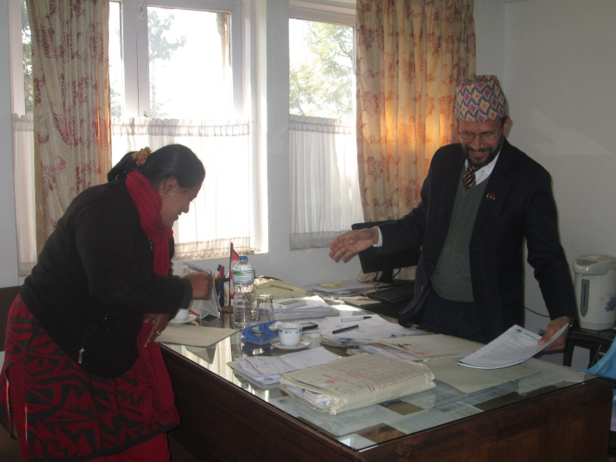
Preparation of policy suggestion report is the major achievement of this project. This policy suggestion report was prepared based on the gaps identified on policy review document and ideas and feedbacks collected form consultation workshops. Policy suggestion report was officially submitted to MoFSC. This policy suggestion report is a representative voice of all forestry sector related civil society organizations Nepal. Government of Nepal/ Ministry of forest and soil conservation is in the process of drafting the new forestry sector strategy incorporating the recommendations from the civil society organizations. FECOFUN as well as other civil society organizations are working closely with government to incorporate their voice and suggestions in new forestry strategy.
Figure. 2 FECOFUN Chairperson Apsara Chapagain handing over the policy recommendations to the Secretary of MoFSC/GoN at MoFSC in 26, January, 2014

Media mobilization
Media coverage was critical to influencing policy-makers and public perceptions on the project. The project also realized that it was important to collaborate with media to educate them on meaningful issues related to democratic governance, participation, and the experiences of marginalized and poor groups, including women. The project managed to encourage the publication of newspaper articles and radio/TV segments which helped to inform the public and build a sense of one nation providing poignant and accurate information to journalists. The media collaboration was very much useful in nationalizing forest management issues at national level and it also helped to make a common understanding on development of new forestry sector strategy. A glimpse of media coverage of project activities is shown in (Annex-3).
Fig: Press conference organized after submitting the policy suggestion report to MoFSC

Impacts
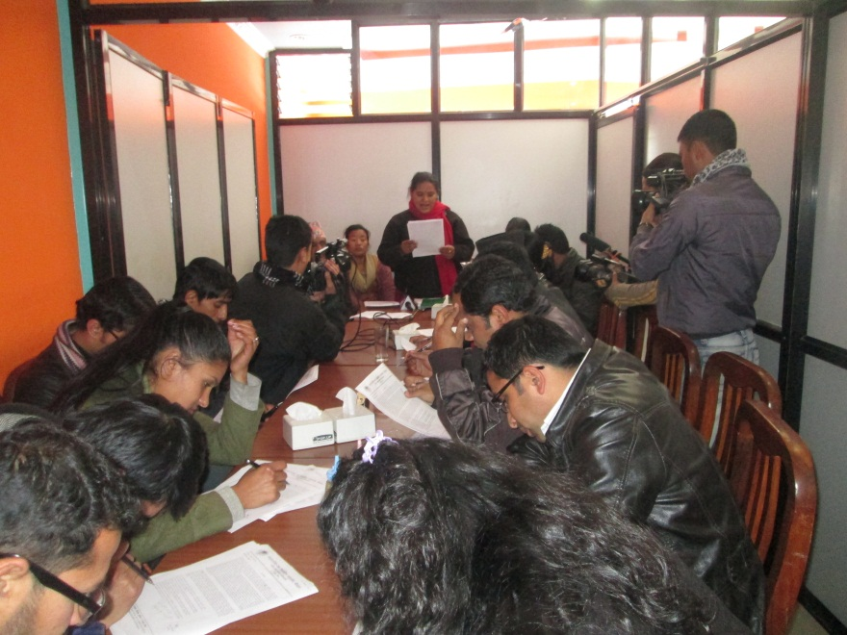
Nepal is on the process of drafting the new constitution. On the other hand a lot of forestry sector related policies and strategies are also in the formulation process led by ministry of forests and soil conservation. This project was designed to influence the policy making process so as to incorporate the view and ideas form the civil society organizations and local communities.
In past policy making process was out of the scene for the local communities as they were formulated in central level. This project aimed to participate the local communities in policy making process and incorporate their view in the new policy and strategy. FECOFUN being the executing agency for the project prepared and submitted the policy suggestion report to the MoFSC. As a result of this MoFSC is preparing the new forestry sector strategy considering the suggestions submitted by FECOFUN on the behalf of all the civil society organizations. Engagement of local communities in policy making process was on the major impact project. As a result of this local communities will fell some ownership in the new document and its matter, which would help to ease the implementation in the future.
Figure. 3 press conference organized after submitting the policy recommendation s to MOFSC at Kathmandu in 26, January, 2014

Sustainability
This project believes that the policy recommendations provided by FECOFUN will be incorporated by MoFSC in the new forest sector strategy. As the project’s success depends on the government’s acceptance and integration of the suggestions and feedbacks obtained through consultation with CSOs and local communities, for this FECOFUN have maintained a close coordination and collaboration with government line agencies at various levels, especially at the ministerial level. FECOFUN will regularly follow up and pressurize the Ministry of Forests and Soil Conservation to incorporate and address the suggestion and feedbacks submitted as policy recommendations using its existing institutional mechanism and resources. Use of different media has also helped to widen the discourse and also to spread the forestry sector issues among various stakeholders.

CONCLUSION, LESSON LEARNED AND RECOMENDATIONS

Conclusion
The status of project implementation is good as all of the activities have been completed according to the project document and annual work plan. The project progress towards the achievement of the project specific objectives and expected outcomes is satisfactory as the planned activities for this phase had been completed. This project intervened on the policy making process, engaged the local communities and other stakeholders in series of consultation to grasp the grass rot voices. It has also developed the common understanding among the various stakeholders as a result of which a single policy recommendations document has been submitted to MoFSC by FECOFUN representing civil society organizations of Nepal.

Lessons learned
Lesson learned during the project design, implementation, management, coordination, monitoring and financial control are described in respective subheadings as follows
Project Design
- Experience has shown that too many decisions concerning project work plan and strategy and objectives have constrained the implementation of the project smoothly which hampered the target achievement progress.
- Involving as broad a range of potential stakeholders and expected beneficiaries as possible in the project design phase is essential to ensure that the final project document is an accurate reflection of reality, a feasible project, and has the potential to become an effective intervention.
- A Project design to focus of the real needs of the beneficiaries by requiring a detailed assessment of the existing situation, and by applying the logical framework method and assuring sustainability and critical assumptions are incorporated.
Implementation
- The goal, objectives and implementing strategies of the project makes the project concept and context clear and visible, and thus enables better monitoring and valuation. The monitoring, reporting, and evaluation components of the project cycle are essential for effective implementation.
- A successful project is the result of not only the accuracy of the technical solution, but also of the acceptance by all the stakeholders involved and the approach to implementing the project.
- At each stage in the project cycle, issues are examined, revised as necessary, and feedback is provided to improve project implementation.
- Regular backstopping and technical support is needed.
Project Management
- Role and responsibility of each project personnel must be clearly defined for effective project management.
- Project management structure must be simple and dynamic rather than complex and rigid.
- Project management and operating guideline is need for effective management.
Coordination
- Coordination and collaboration with multi-stakeholders result in synergetic relationship
- Joint proactive effort of multiple stakeholders necessary for enterprise development
- More effort and coordination needed to secure counterpart funds for enterprise establishment
- Coordination and collaboration is needed to share the skills, knowledge and ideas
- Coordination and collaboration with government line agencies is foremost for the policy intervention.
Monitoring
- Periodic monitoring is necessary to maintain good governance at community level
- Regular backstopping is needed for sustainability.
Financial Control
- Financial operating guideline is foremost for the financial management.

Project progress status could be ranked as satisfactory, dissatisfactory, moderately satisfactory, moderately dissatisfactory
3≤X≤5: Satisfactory, 1≤X<3: Unsatisfactory. Score is average of individual performance variables.

